Reference link: <https://youtu.be/2bx9Os2gPu4>

Regularization in machine learning is a set of techniques used to ensure that a machine learning model can generalize to new data within the same data set.

These techniques can help reduce the impact of noisy data that falls outside the expected range of patterns. Regularization can also improve the model by making it easier to detect relevant edge cases within a classification task.

As such, regularization is an important tool that can be used by data scientists to improve model training to achieve better generalization, or to improve the odds that the model will perform well when exposed to unknown examples.

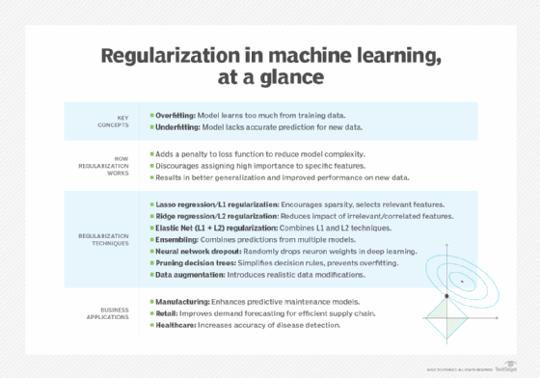

## Key concepts in regularization, explained

### What is overfitting?

The term overfitting is used to describe a model that has learned too much from the training data. This can include noise, such as inaccurate data accidentally read by a sensor or a human deliberately inputting bad data to evade a spam filter or fraud algorithm. It can also include data specific to that particular situation but not relevant to other use cases, such as a store shelf layout in one store that might not be relevant to different stores in a stockout predictor.

### What is underfitting?

Underfitting occurs when a model has not learned to map features to an accurate prediction for new data. Greenstein said that regularization can sometimes lead to underfitting. In that case, it is important to change the influence that regularization has during model training. Underfitting also relates to bias and variance.

### What is bias?

Bantilan described bias in machine learning as the degree to which a model's predictions agree with the actual [ground truth](https://www.techtarget.com/searchcio/answer/What-is-ground-truth-in-AI-and-deep-learning). For example, a spam filter that perfectly predicts the spam/not-spam labels in training data would be a low-bias model. It could be considered high-bias if it was wrong all the time.

### What is variance?

Variance characterizes the degree to which the model's predictions can handle small perturbations in the training data. One good test is removing a few records to see what happens, Bantilan said. If the model's predictions remain the same, then the model is considered low-variance. If the predictions change wildly, then it is considered high-variance.

## Machine regularization techniques

There are a range of different regularization techniques. The most common approaches rely on statistical methods such as Lasso regularization (also called L1 regularization), Ridge regularization (L2 regularization) and Elastic Net regularization, which combines both Lasso and Ridge techniques. Various other regulation techniques use different principles, such as ensembling, neural network dropout, pruning decision tree-based models and data augmentation

**Lasso regression**AKA**L1 regularization.**The Lasso regularization technique, an acronym for least absolute shrinkage and selection operator, is derived from calculating the median of the data. A median is a value in the middle of a data set. It calculates a penalty function using absolute weights. Kearney's Thota said this regularization technique encourages sparsity in the model, meaning it can set some coefficients to exactly zero, effectively performing feature selection.

**Ridge regression**AKA**L2 regularization.**Ridge regulation is derived from calculating the mean of the data, which is the average of a set of numbers. It calculates a penalty function using a square or other exponent of each variable. Thota said this technique is useful for reducing the impact of irrelevant or correlated features and helps in stabilizing the model's behavior.

**Elastic Net (L1 + L2) regularization.**Elastic Net combines both L1 and L2 techniques to improve the results for certain problems.

**Ensembling.**This set of techniques combines the predictions from a suite of models, thus reducing the reliance on any one model for prediction.

**Neural network dropout.** This process is sometimes used in [deep learning algorithms](https://www.techtarget.com/searchenterpriseai/definition/deep-learning-deep-neural-network) comprised of multiple layers of [neural networks](https://www.techtarget.com/searchenterpriseai/definition/neural-network). It involves randomly dropping out the weights of some neurons. Bantilan said this forces the deep learning algorithm to learn an ensemble of sub-networks to achieve the task effectively.

**Pruning decision tree-based models.** This is used in tree-based models like [decision trees](https://www.techtarget.com/searchenterpriseai/definition/decision-tree-in-machine-learning). The process of pruning branches can simplify the decision rules of a particular tree to prevent it from relying on the quirks of the training data.

**Data augmentation.** This family of techniques uses prior knowledge about the data distribution to prevent the model from learning the quirks of the data set. For example, in an image classification use case, you might flip an image horizontally, introduce noise, blurriness or crop an image. "As long as the data corruption or modification is something we might find in the real world, the model should learn how to handle those situations," Bantilan said

Reference link: <https://www.techtarget.com/searchenterpriseai/feature/Machine-learning-regularization-explained-with-examples>

In Juperteblab terminal Install: Seaborn, pandas, numpy and matplolib

Pip install numpy

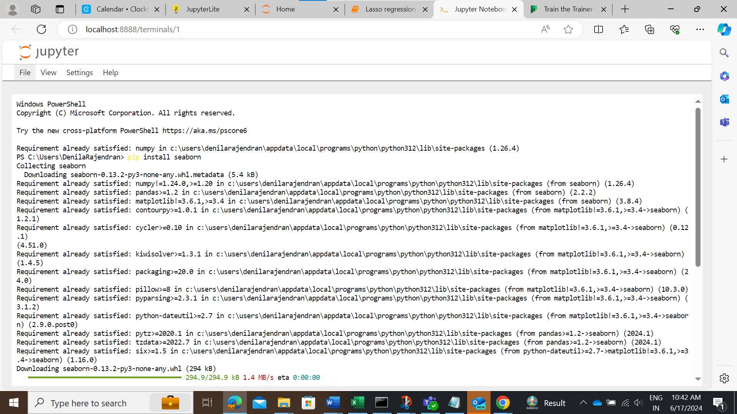

Code:

[Lasso regression new](http://localhost:8888/notebooks/Lasso%20regression%20new.ipynb)

Refer link: <https://youtu.be/VqKq78PVO9g>

pip install -U scikit-learn (on terminal)

Ref Link for sklearn <https://scikit-learn.org/stable/modules/generated/sklearn.linear_model.LinearRegression.html>

Ref link: [Linear Regression in Python Sklearn with Example - MLK - Machine Learning Knowledge](https://machinelearningknowledge.ai/linear-regression-in-python-sklearn-with-example/)

***Thank you***